**Name: Dhvani Patel**

**Roll no: 21BCP116**

**Digital Electronics and Computer Organization Lab**

**ASSIGNMENT 3**

Question: 1Implement the following expression using the Verilog Hardware Description Language (HDL)then compare with truth table whether your circuit produced same output or not? Moreover, verify your circuit against the waveform.

1.F(A, B, C)= A’BC + AB’C + ABC

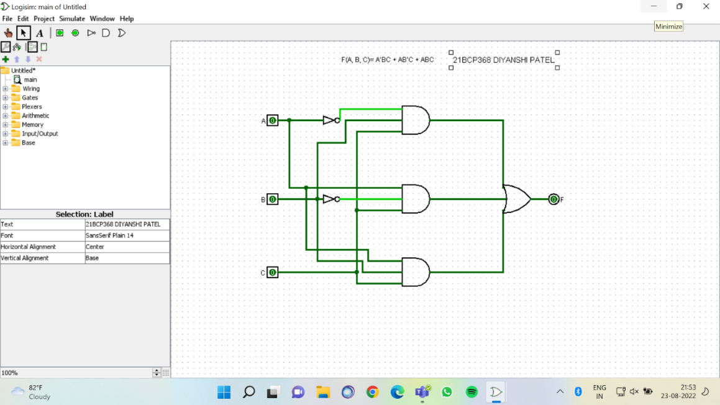

FIG 1.1 CIRCUIT DIAGRAM FOR THE GIVEN EXPRESSION

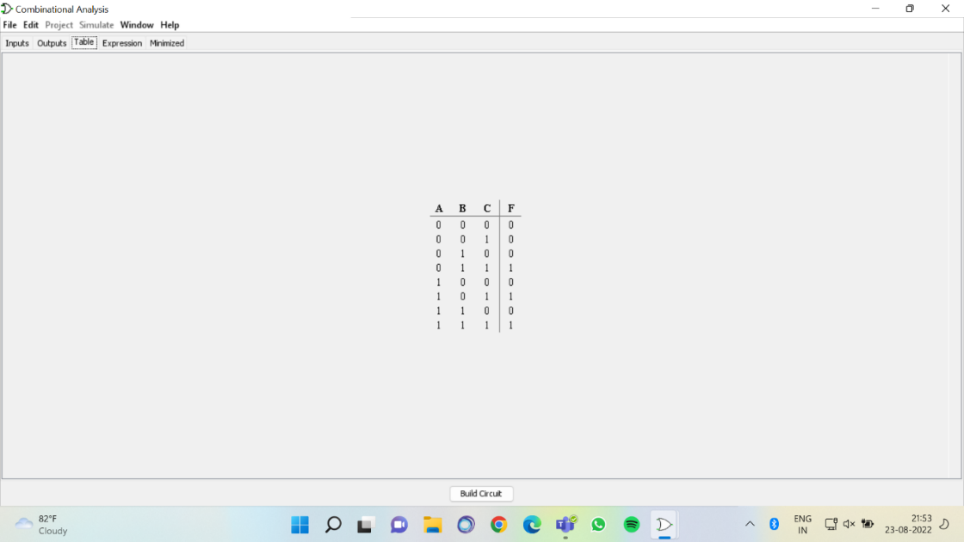

FIG 1.2 TRUTH TABLE FOR THE GIVEN EXPRESSION

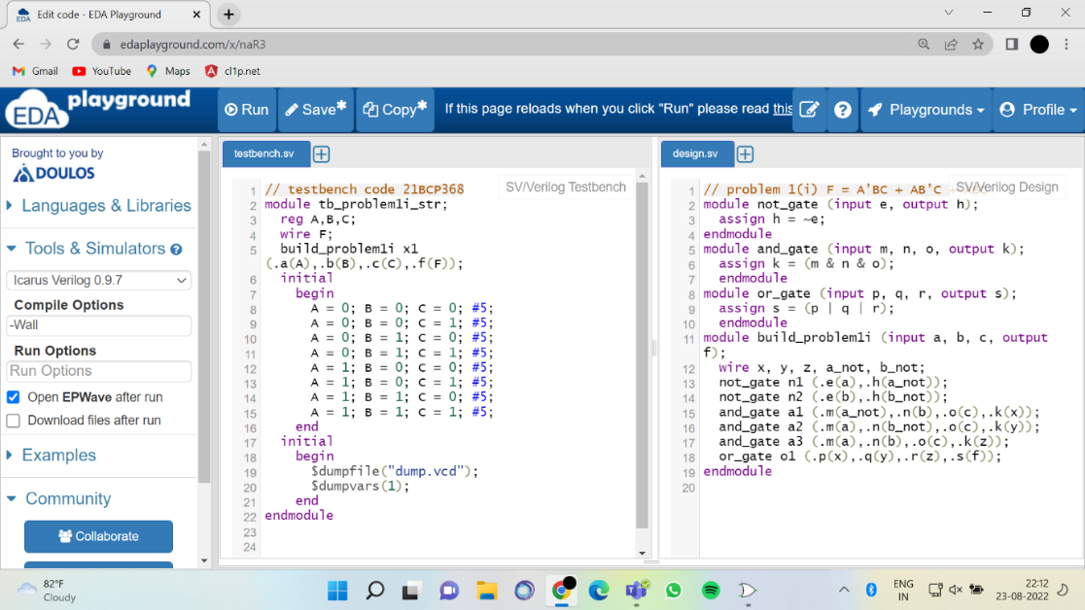

FIG 1.3 Testbench code for the verification of your Verilog code for given expression

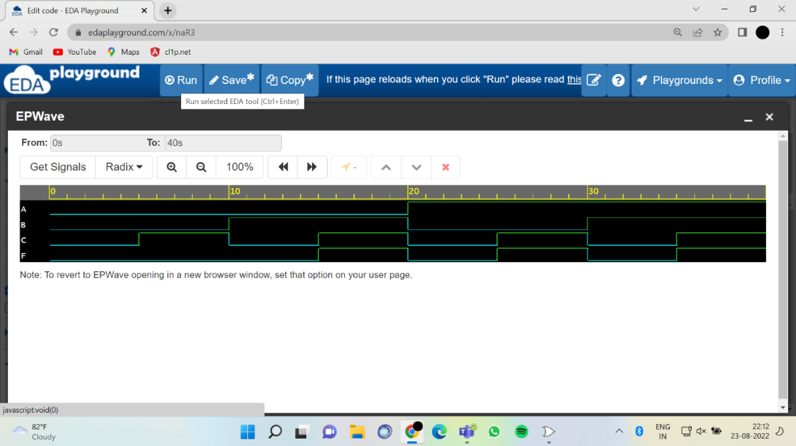

FIG1.4 Output of Verilog code to given expression

2.F(A, B, C, D)=ABCD’ + A’BC D+ AB’CD’ + ABC 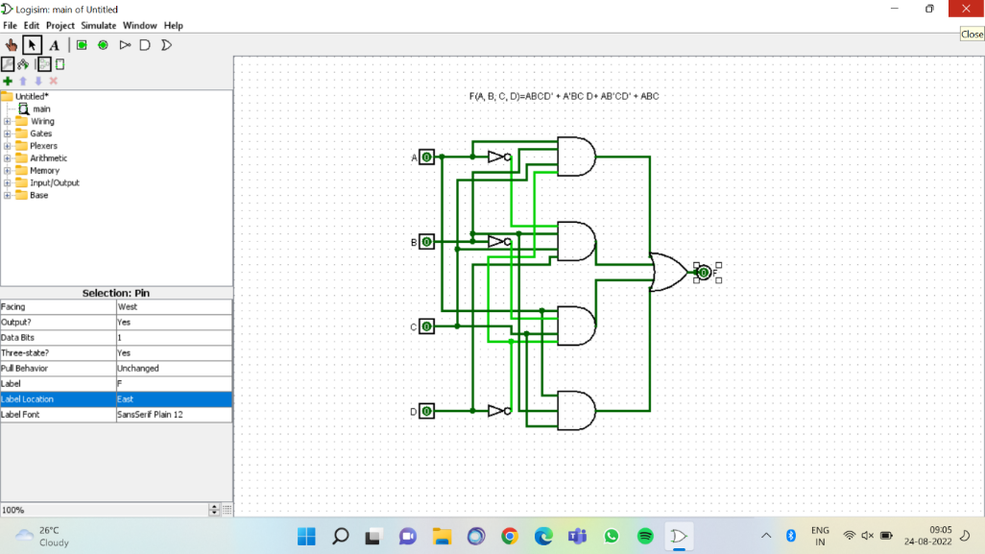

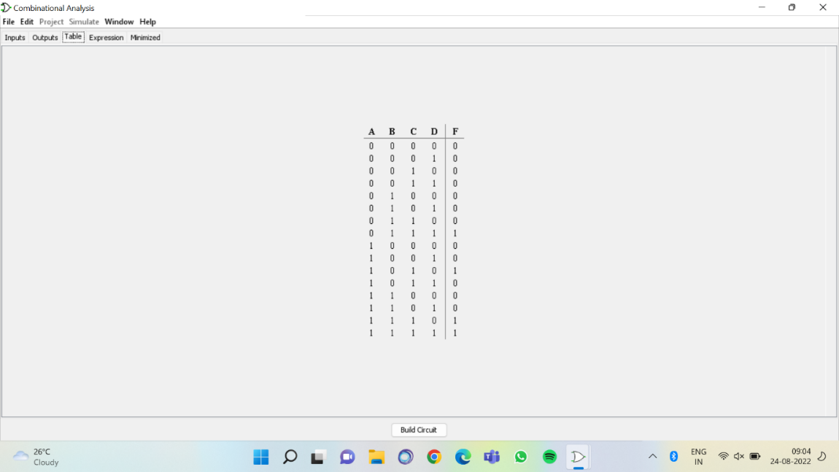

FIG 1.6 TRUTH TABLE FOR THE GIVEN EXPRESSION

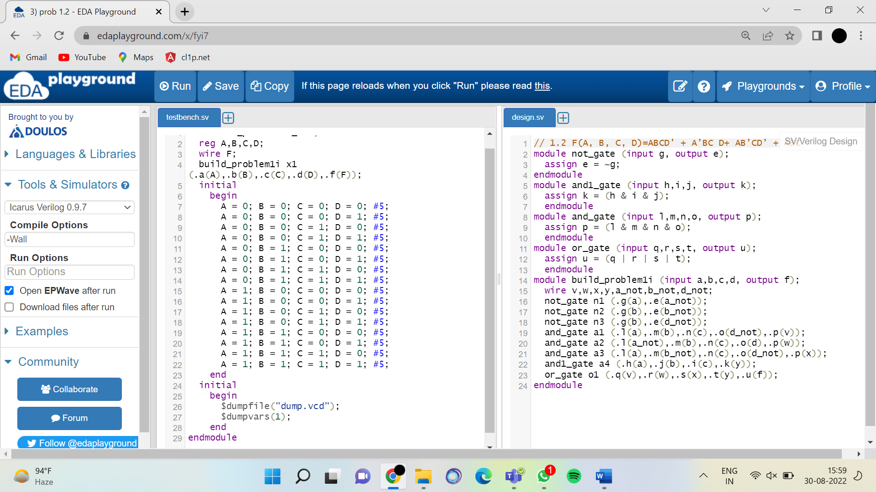

FIG 1.7 Testbench code for the verification of your Verilog code for given expression

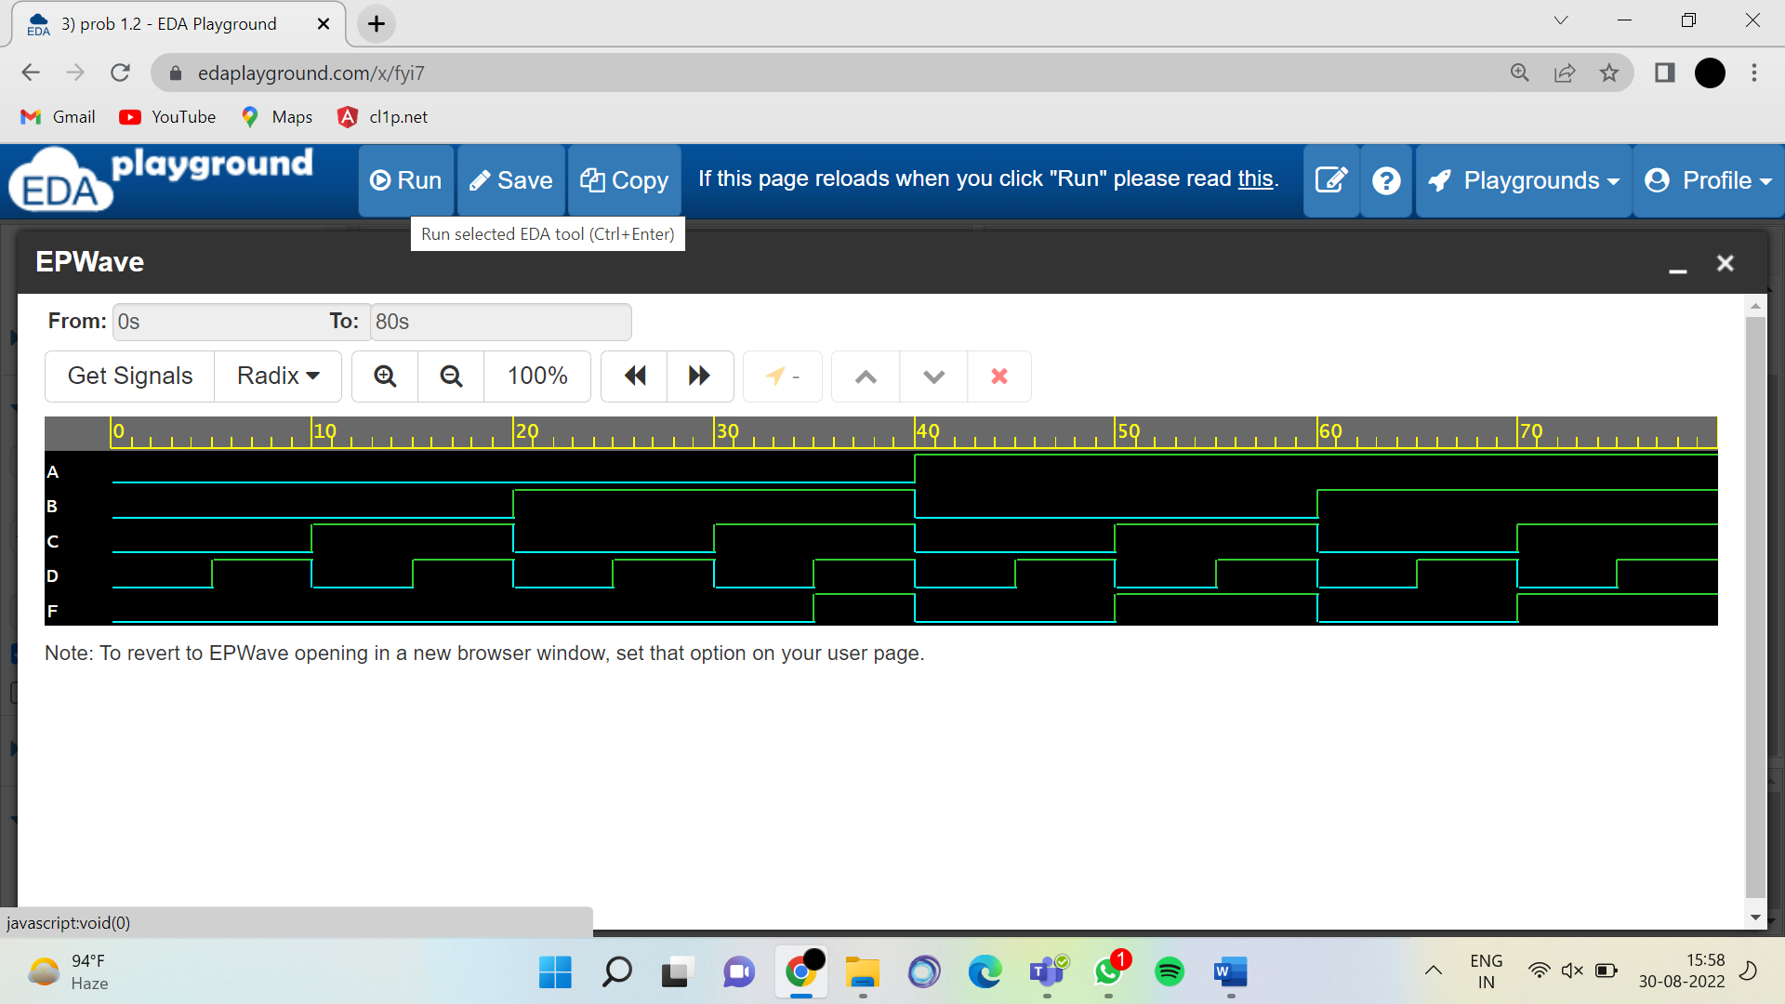

4.F(A, B)= (A’+B’) (A+B’) (A’+B) (A+B)

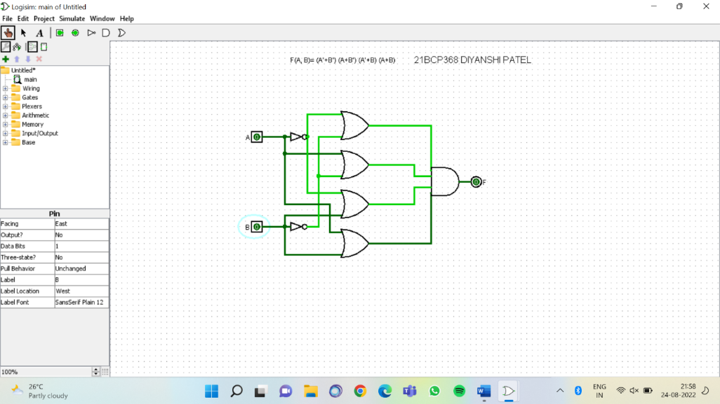

FIG 1.9 CIRCUIT DIAGRAM FOR THE GIVEN EXPRESSION

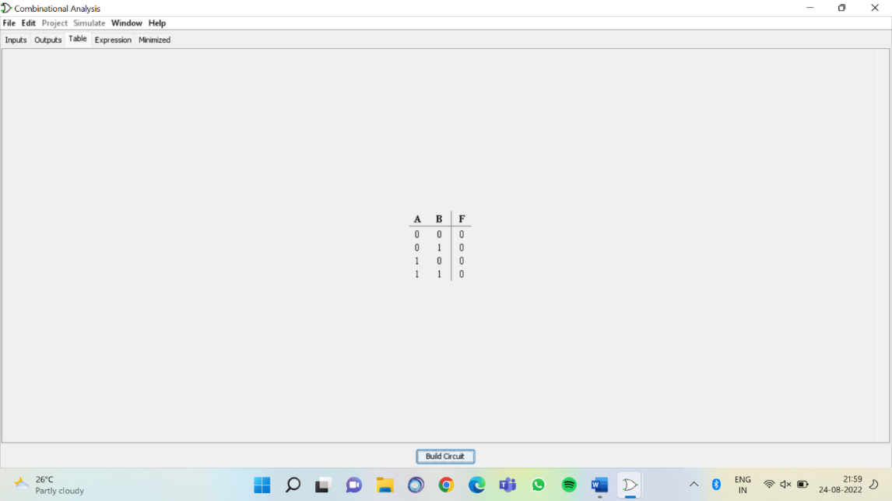

FIG 1.10 TRUTH TABLE FOR THE GIVEN EXPRESSION

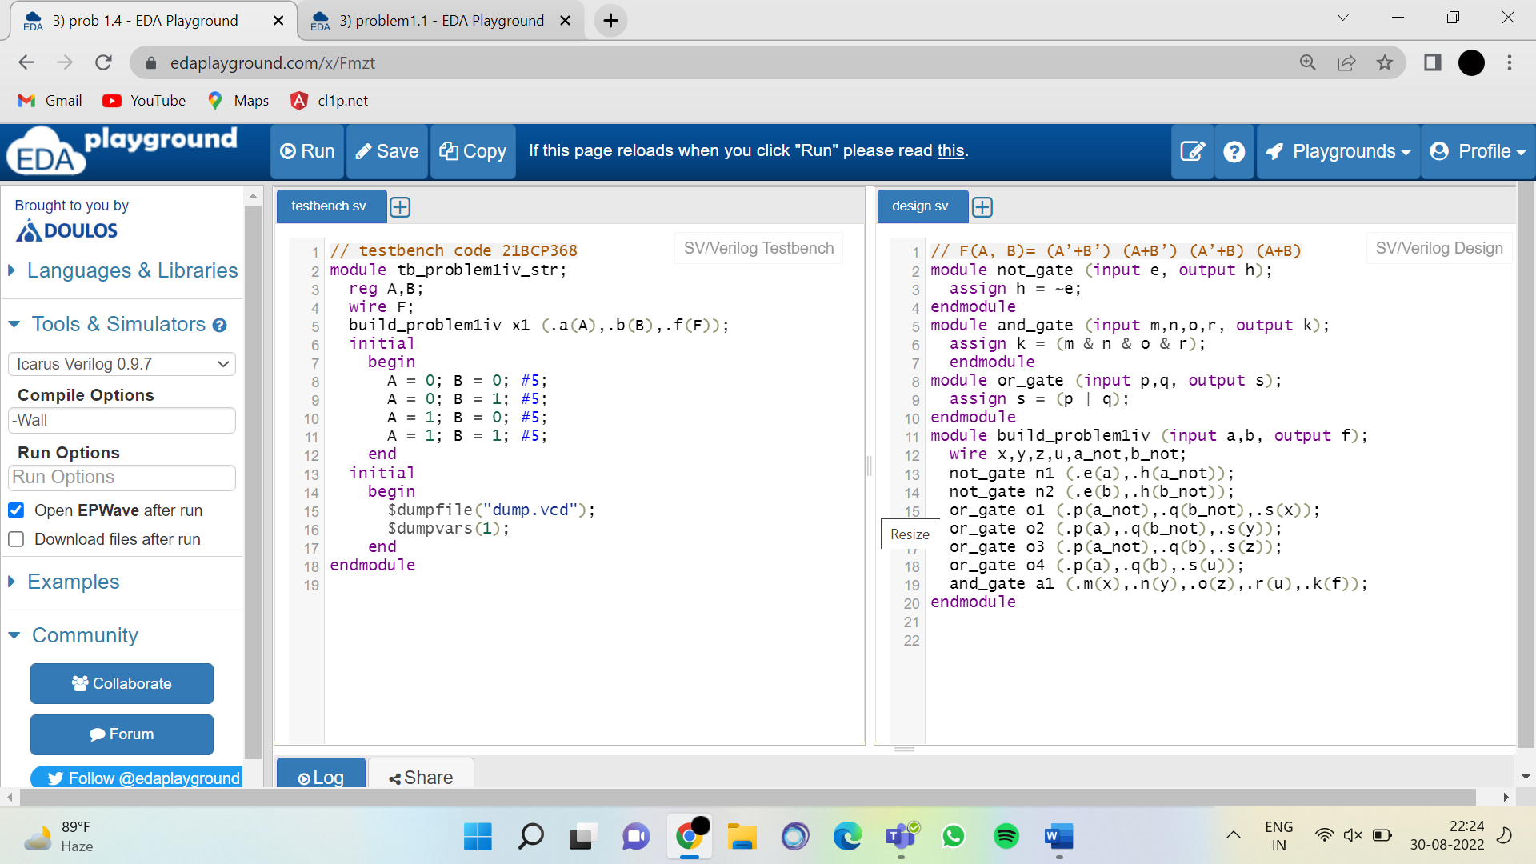

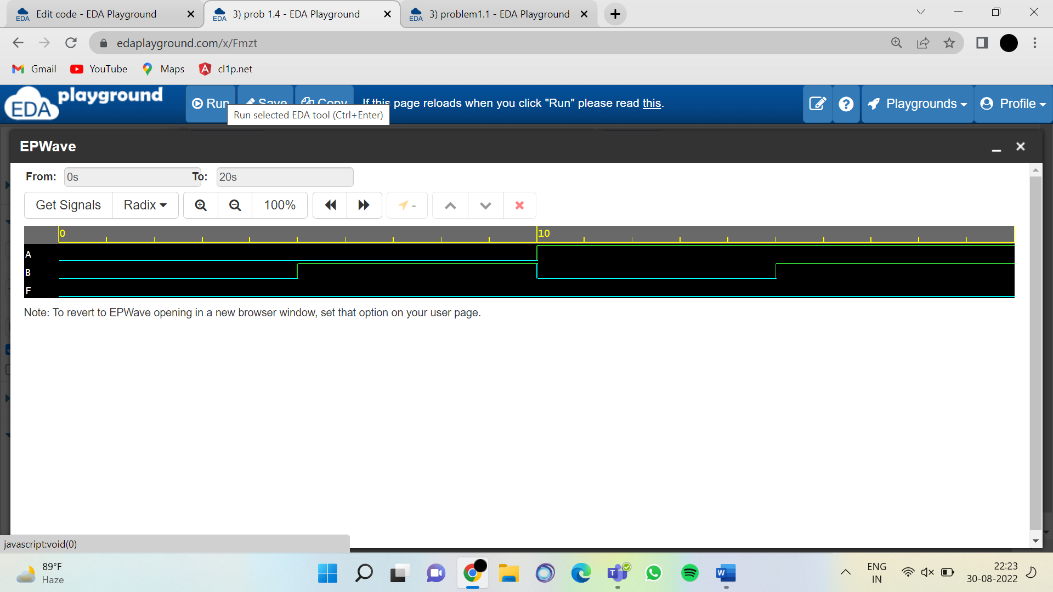

FIG1.12 Output of Verilog code to given expression

5.F(A, B)= ((A.B’)’+((A)’(B)’)’)’

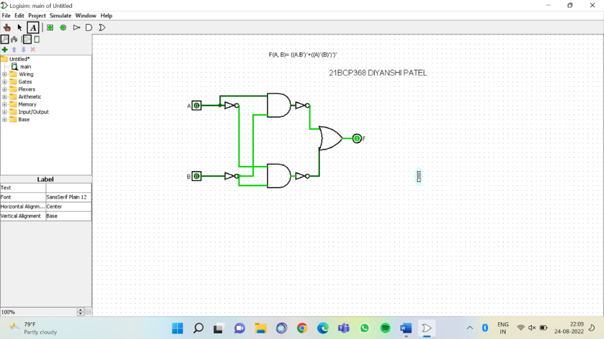

FIG 1.11 CIRCUIT DIAGRAM FOR THE GIVEN EXPRESSION

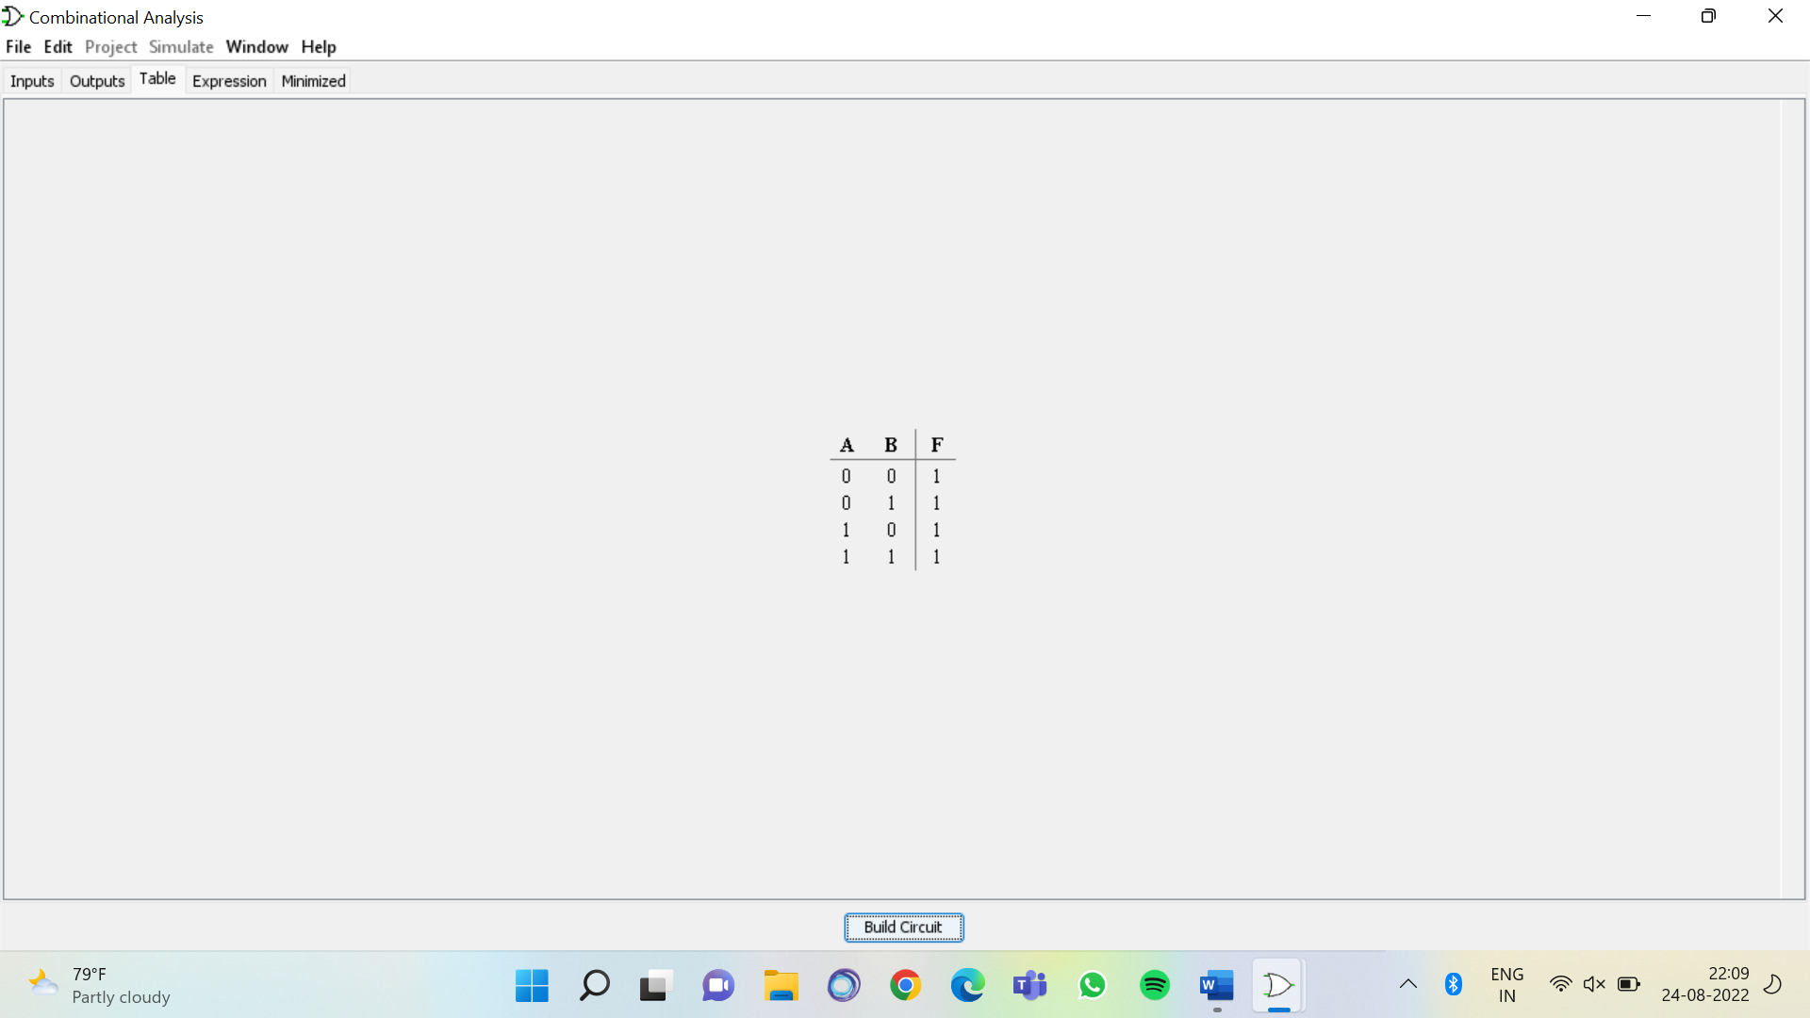

FIG 1.12 TRUTH TABLE FOR THE GIVEN EXPRESSION

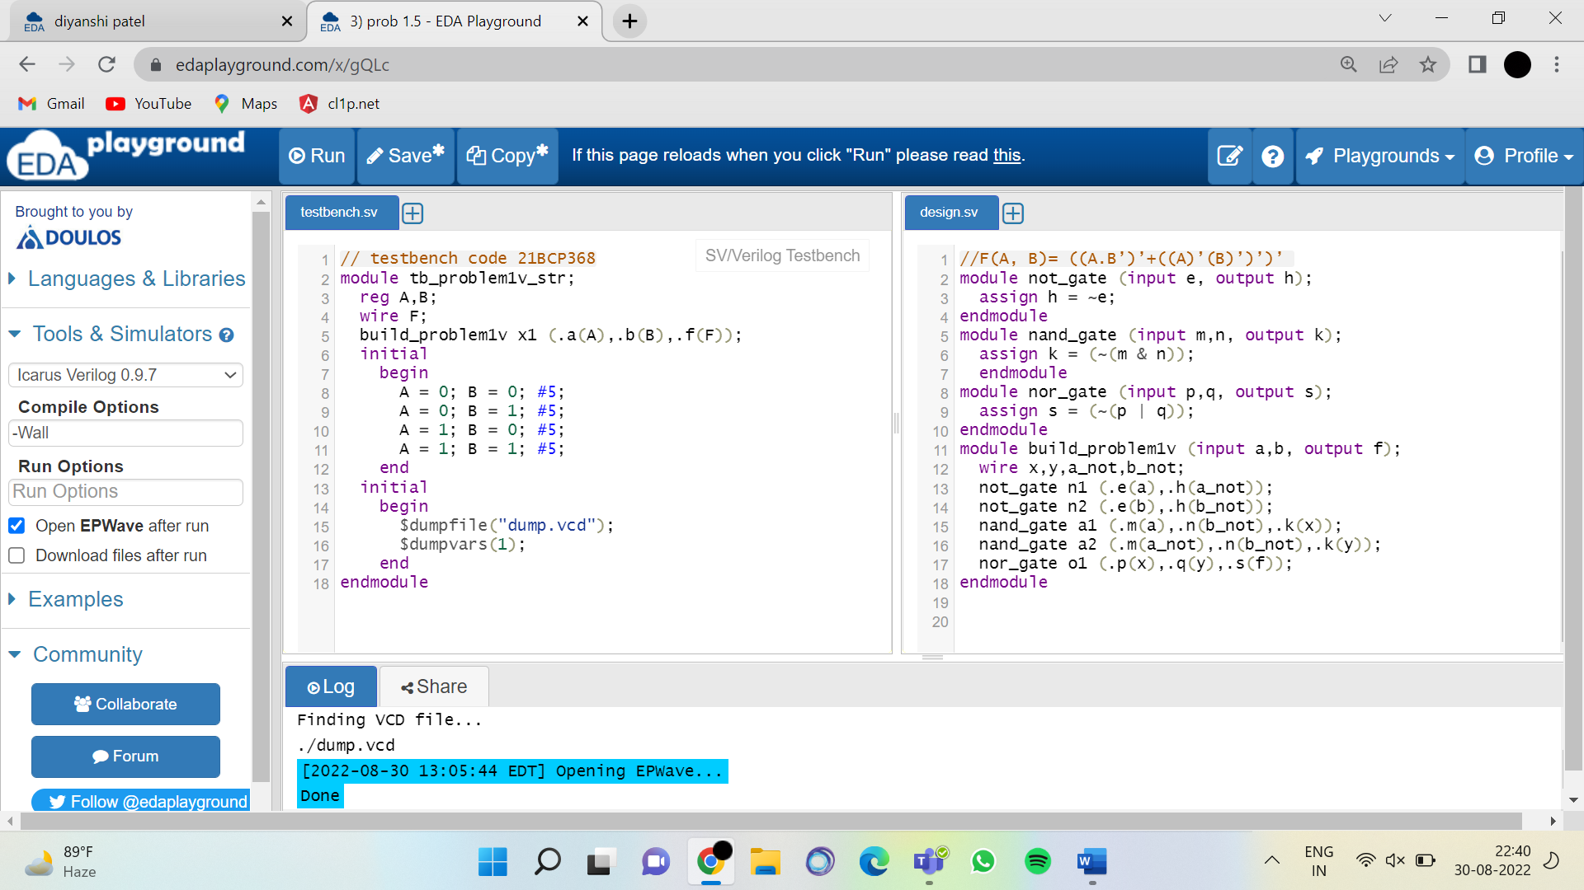

FIG 1.13 Testbench code for the verification of your Verilog code for given expression

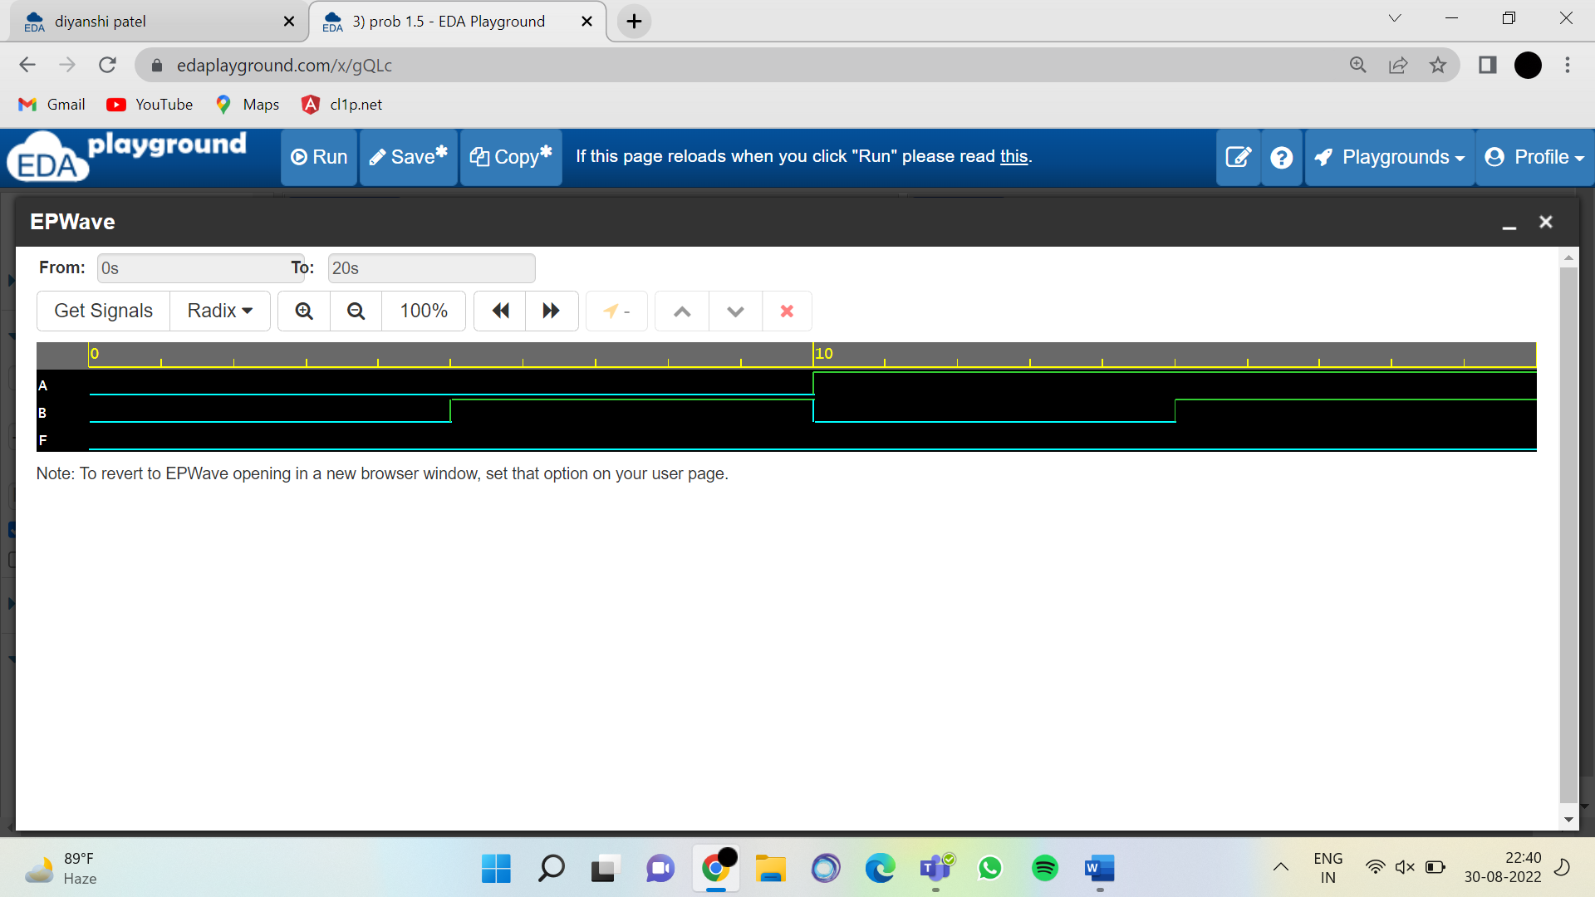

FIG1.14 Output of Verilog code to given expression

6.F(A, B)= (((A)’+B)’. ((A)’+(B)’)’)’

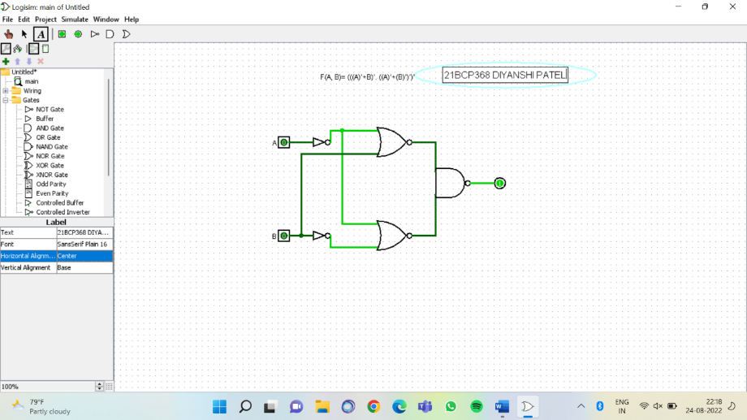

FIG 1.15 CIRCUIT DIAGRAM FOR THE GIVEN EXPRESSION

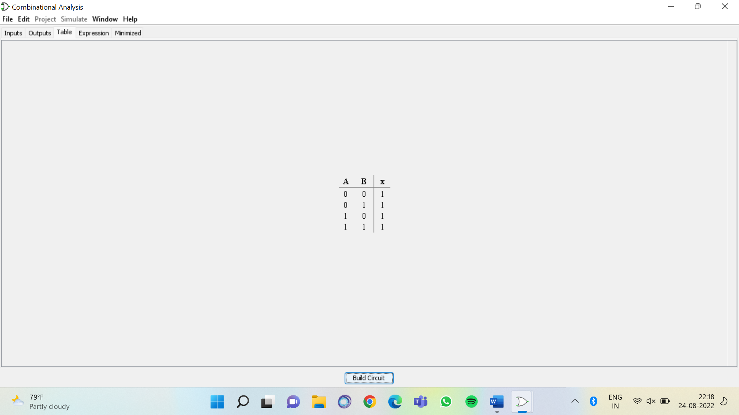

FIG 1.16 TRUTH TABLE FOR THE GIVEN EXPRESSION

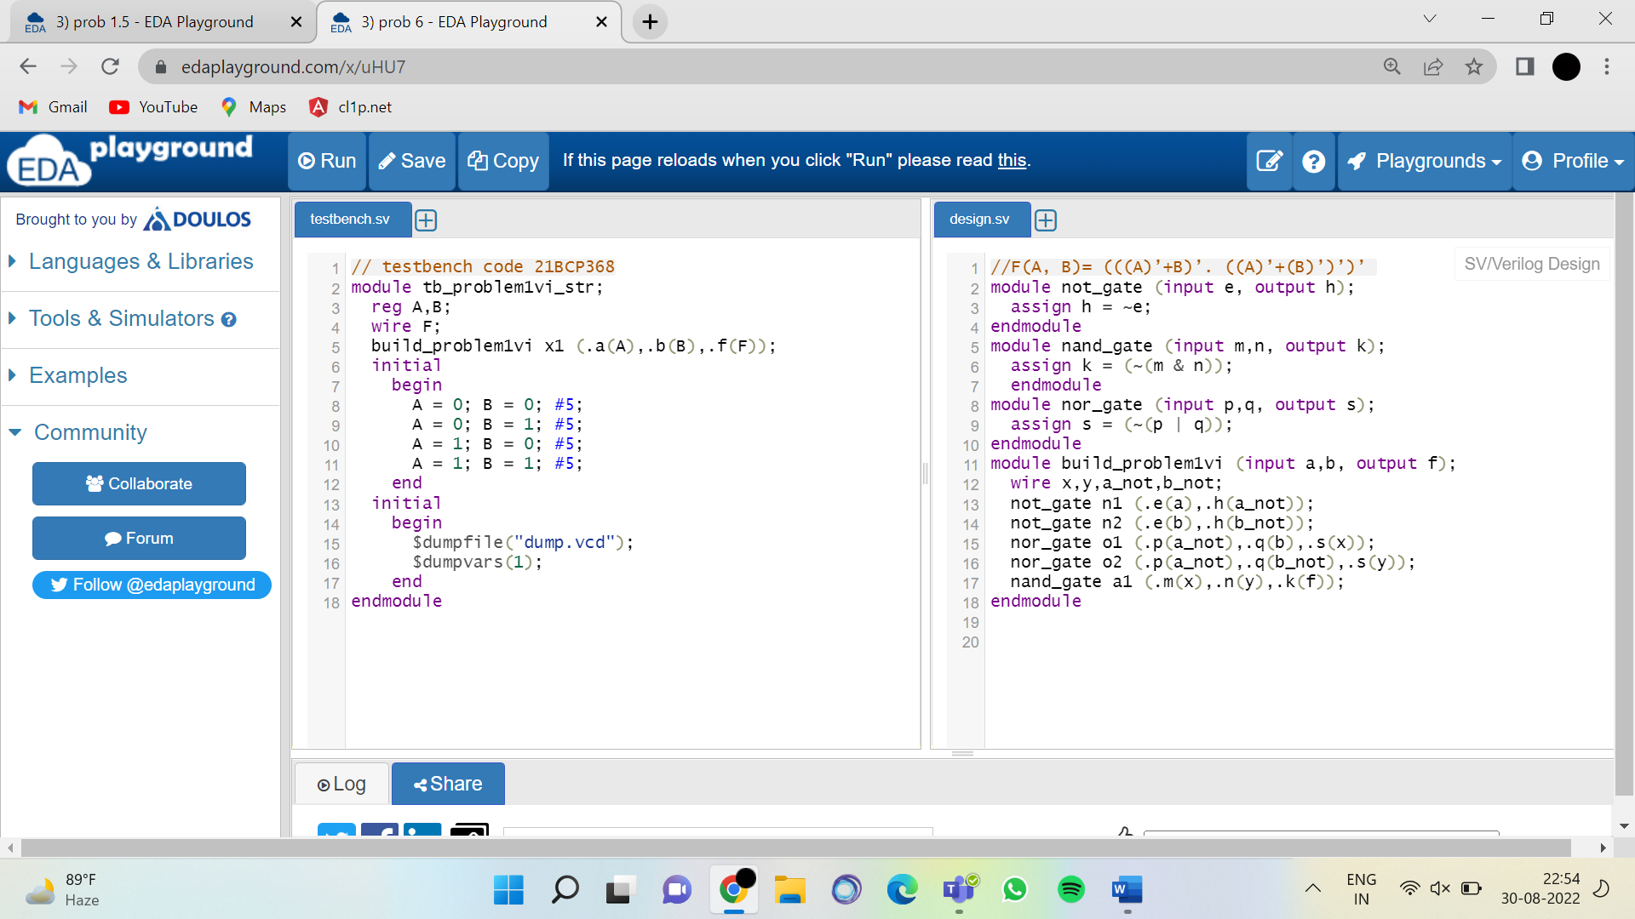

FIG 1.17 Testbench code for the verification of your Verilog code for given expression

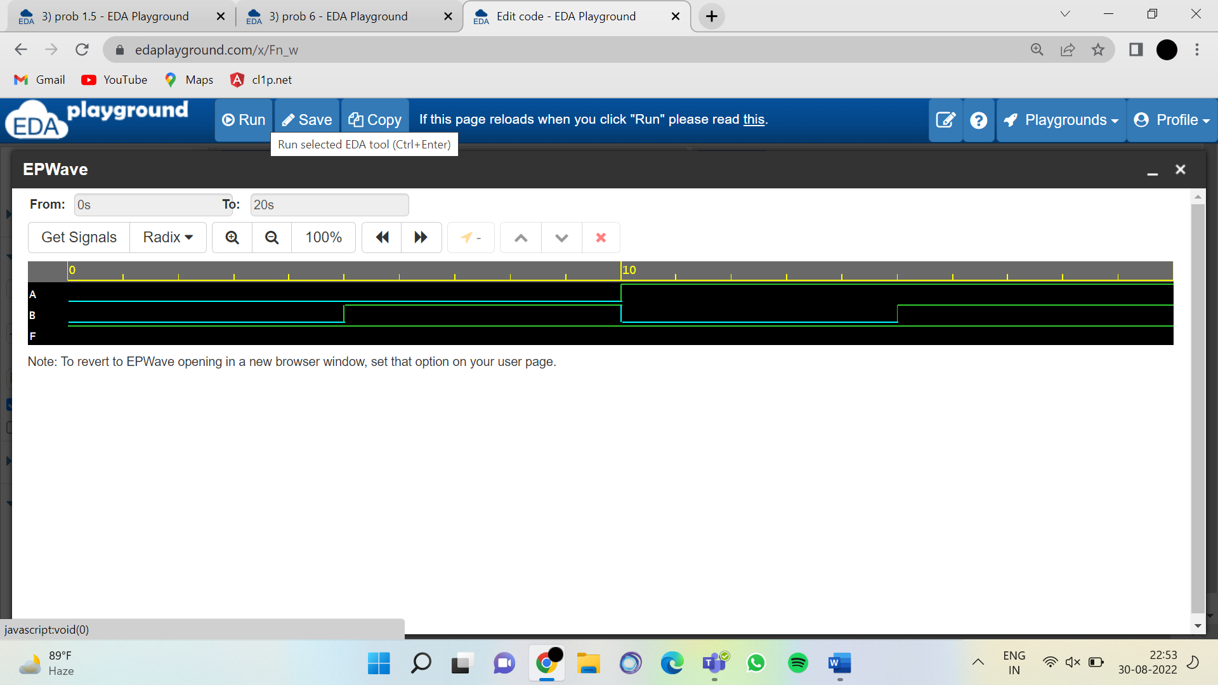

FIG1.18 Output of Verilog code to given expression

Question: 2Implement the XOR gate using Behavioural and Structural code (shown in Fig: 1) of Verilog Hardware Description Language.

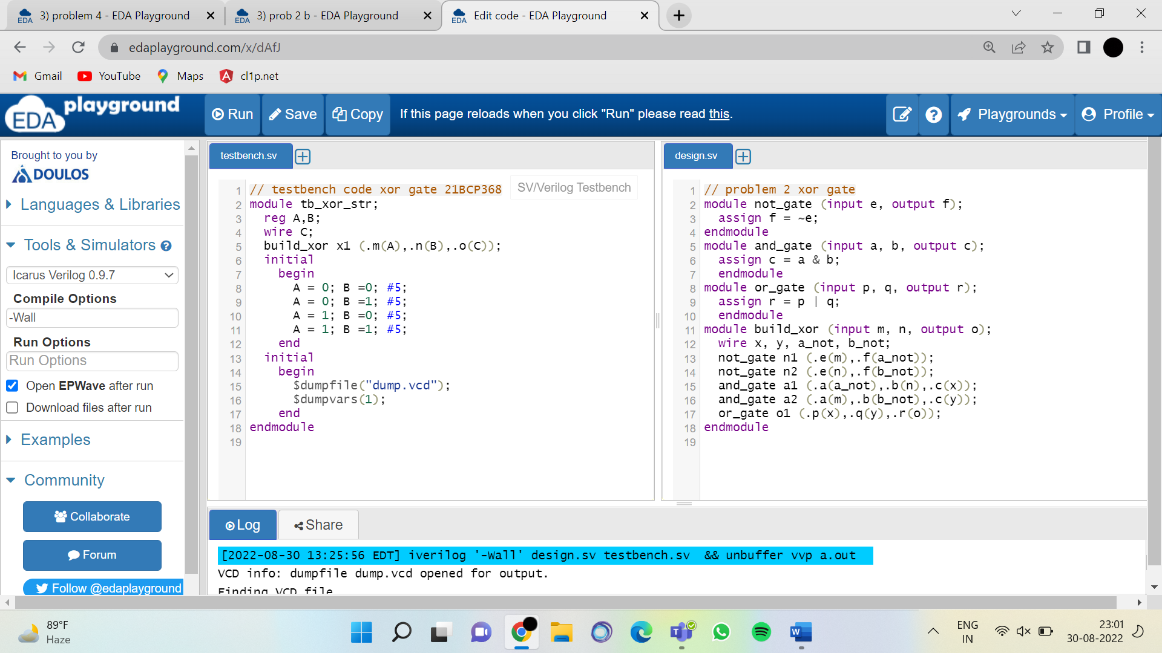

FIG 2.1 Behavioural code of Verilog for XOR gate

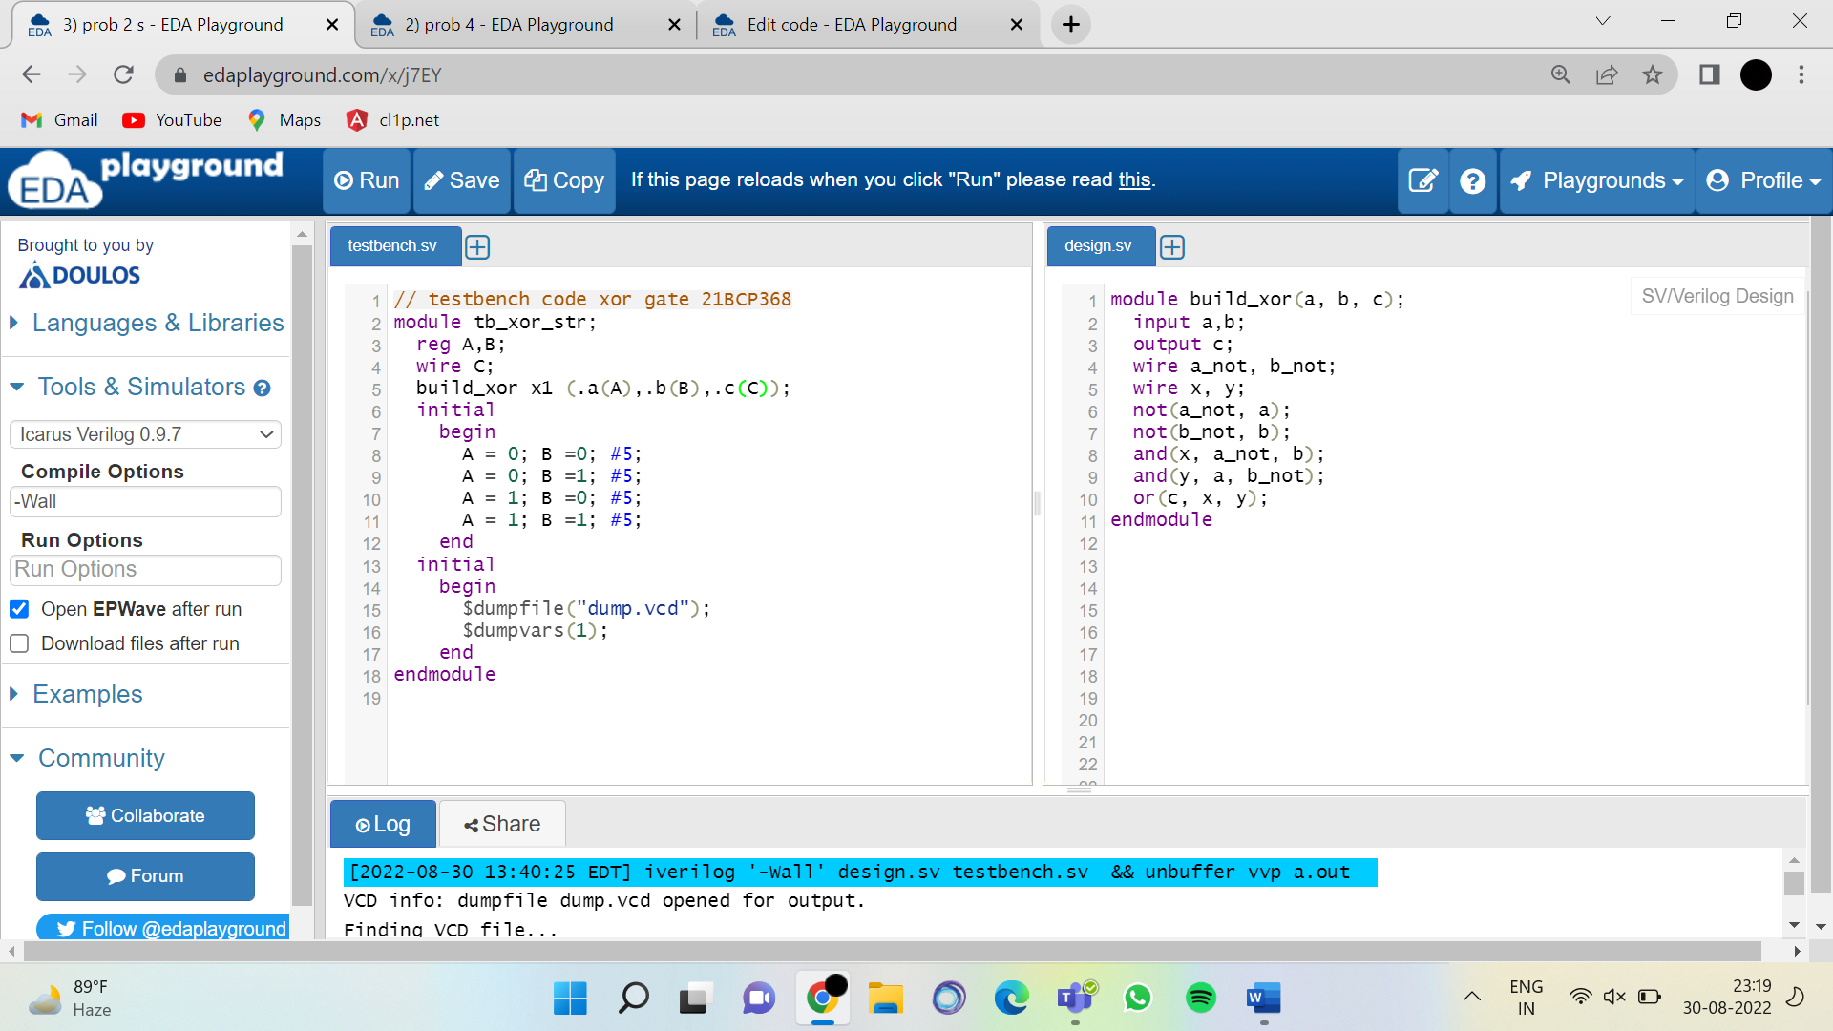

FIG 2.2 Structural code of Verilog for XOR gate

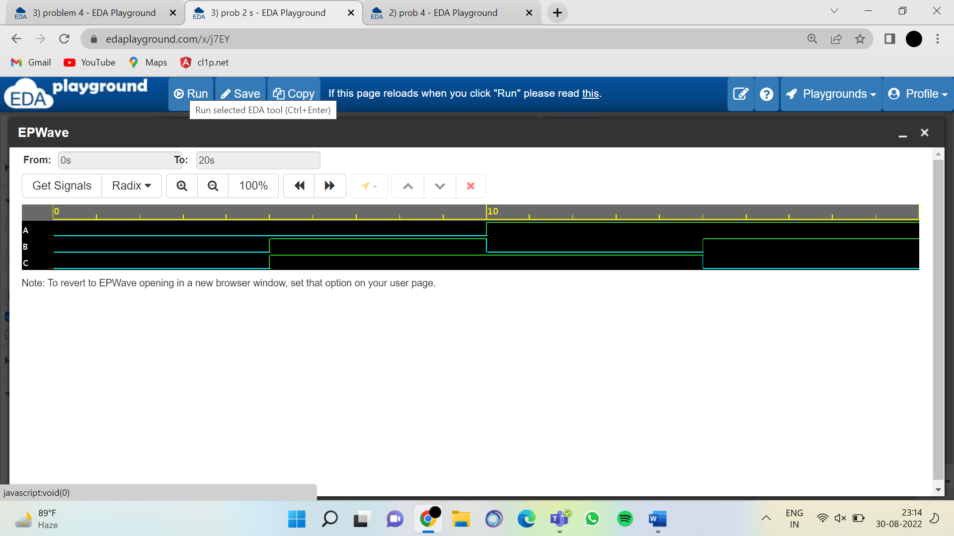

Fig 2.3 Output of given structural and behavioural code of XOR

Question: 3: Implement the following expression using the Verilog Hardware Description Language (HDL) (Structural Coding).

1.F(A, B, C)=(A’+B’+C’)(A+B’+C’)(A’+B+C’)(A’+B’)

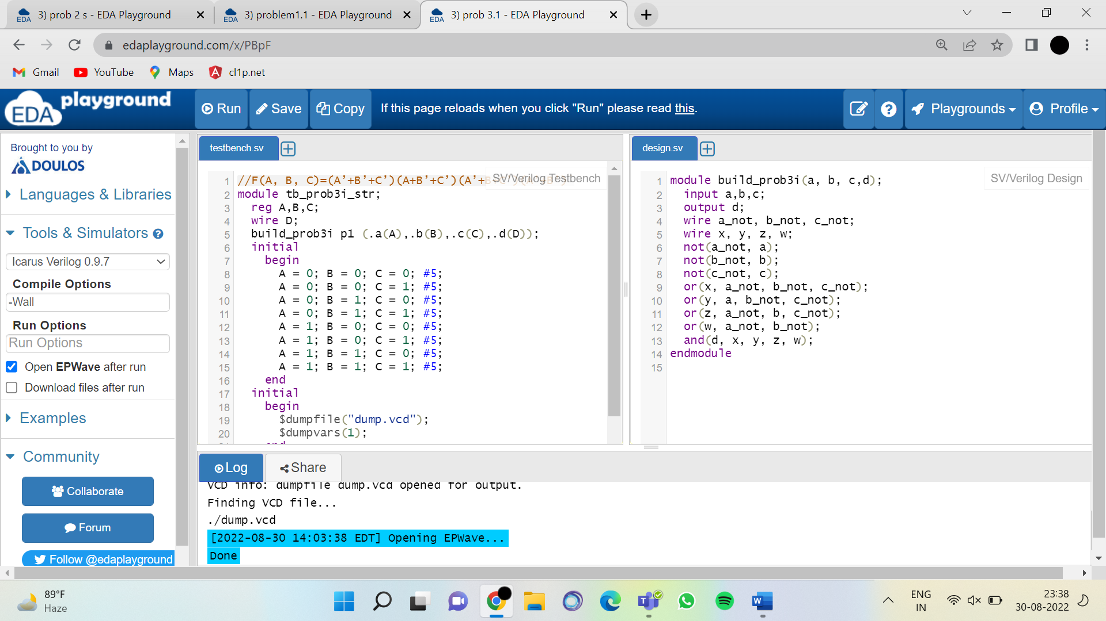

FIG 3.1 Structural code of Verilog for given expression

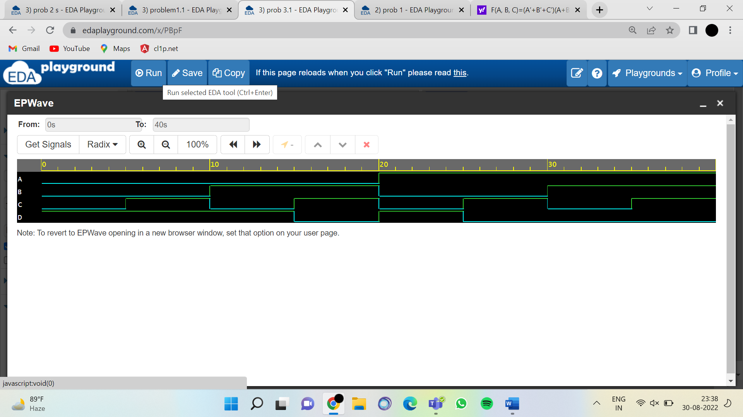

FIG3.2 Output of Verilog code to given expression

2.F(A,B,C,D,E)=((A+B).(C+D+E))’

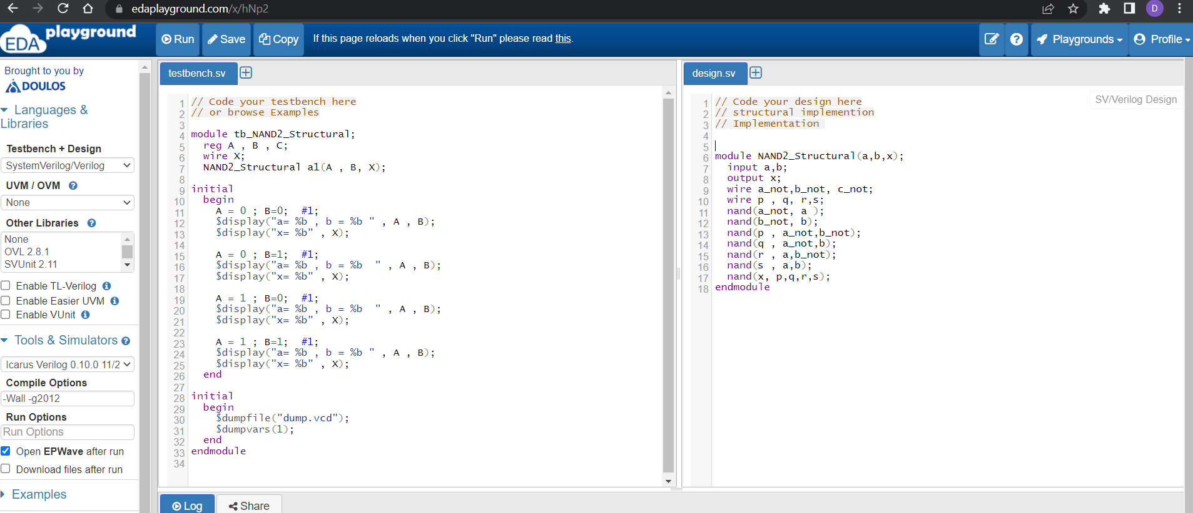

FIG 3.3 Structural code of Verilog for given expression

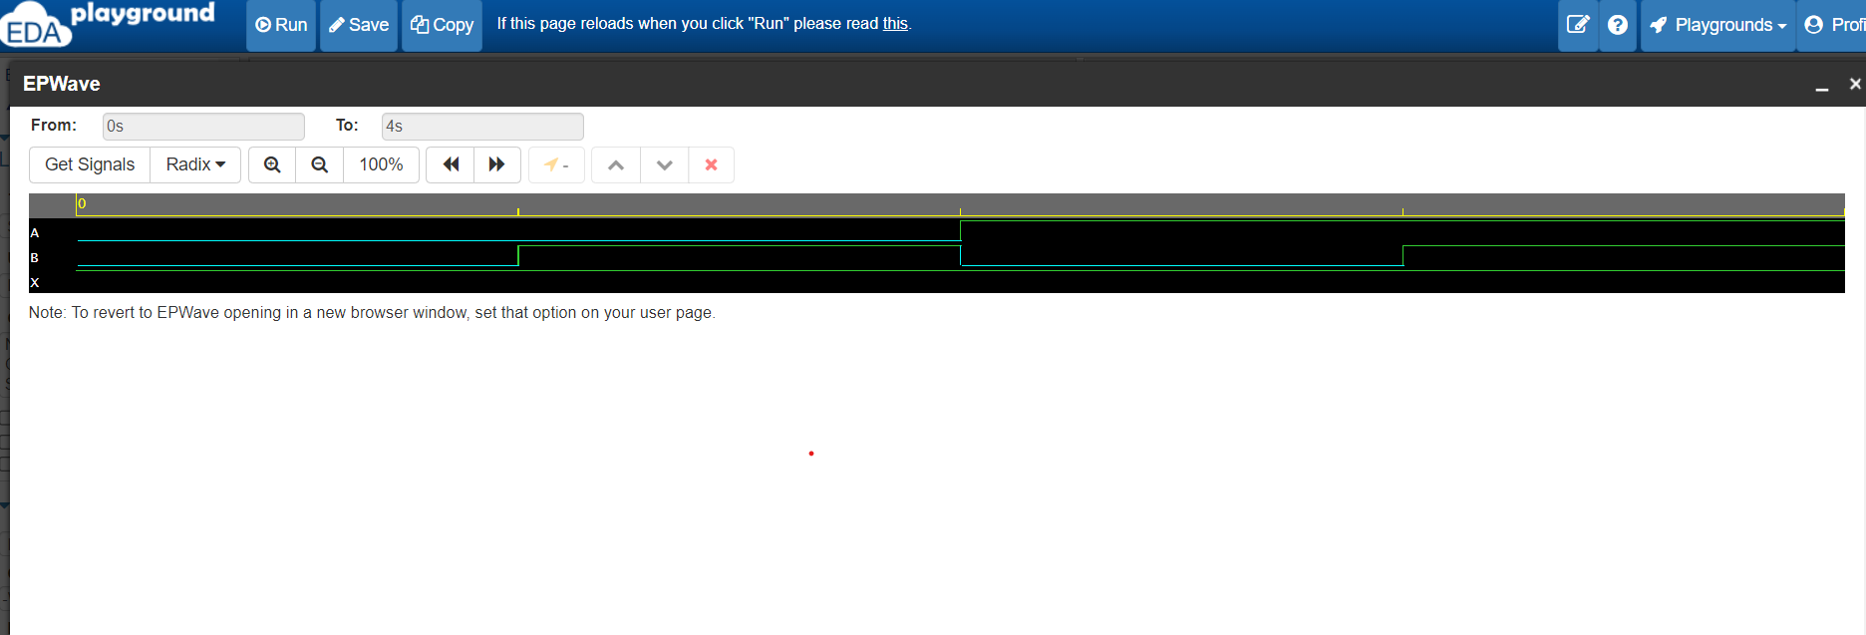

FIG3.4 Output of Verilog code to given expression

Question: 3 Implement the following expression using universal NAND and NOR gate. Write downVerilog Structural and Behavioral code for that expression.

1.F(A, B, C)=(AB’C) + (AB’C’)

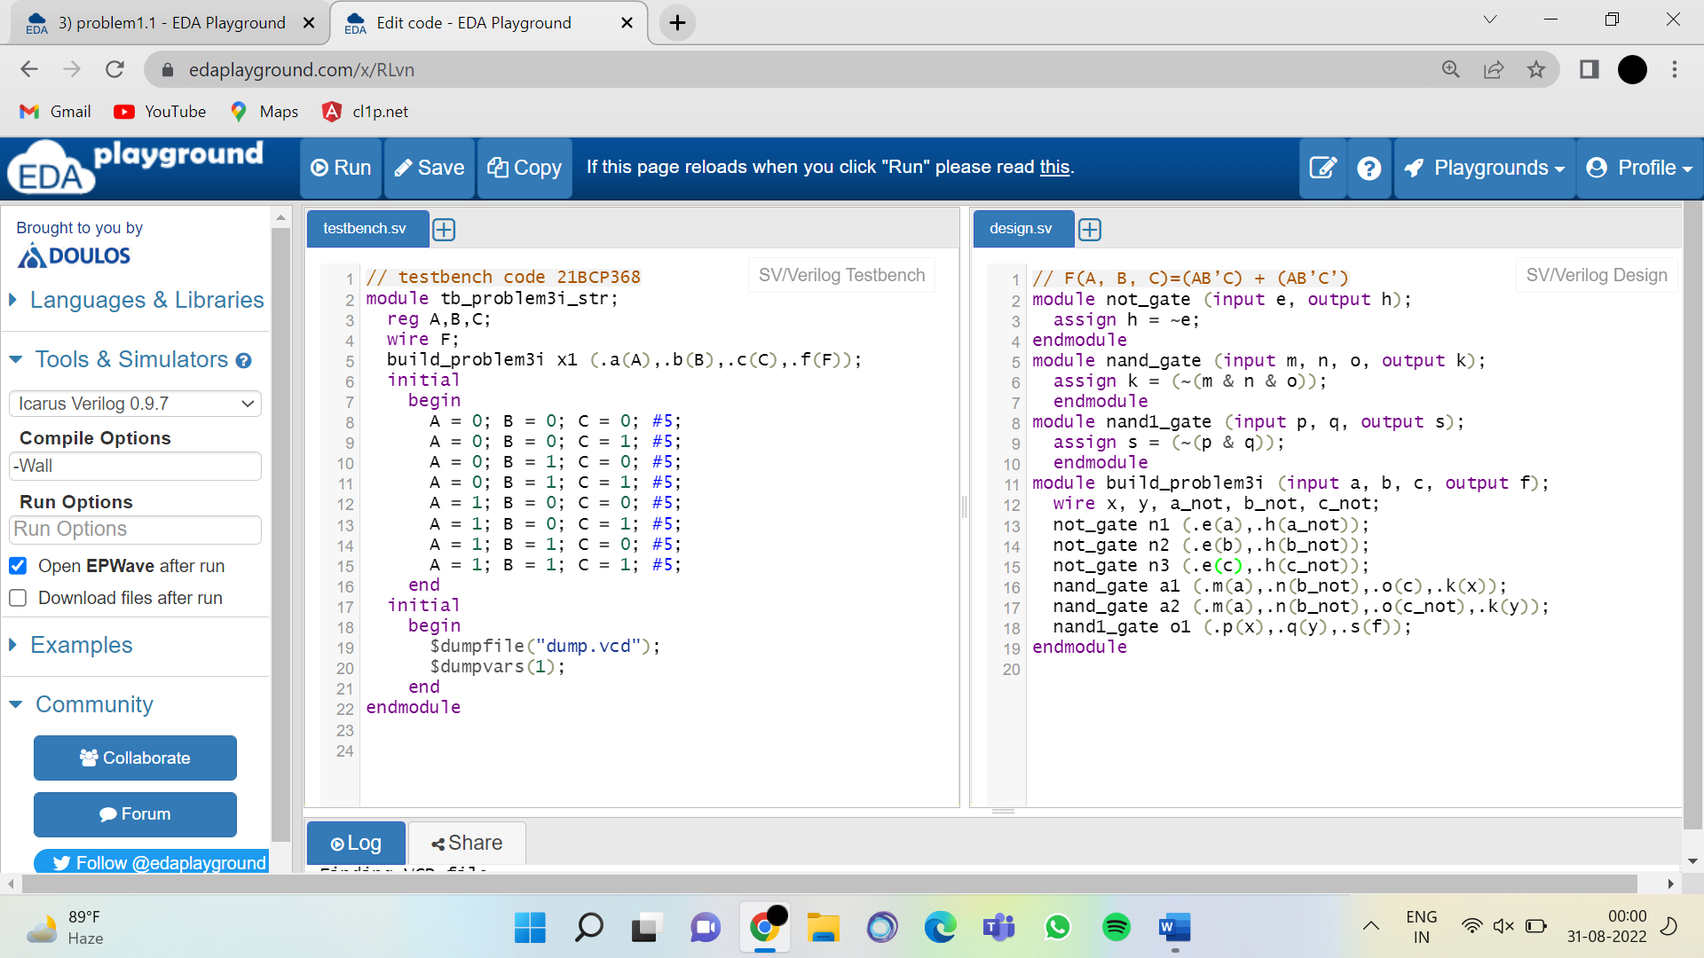

FIG 3.3 Behavioural code of Verilog for given expression

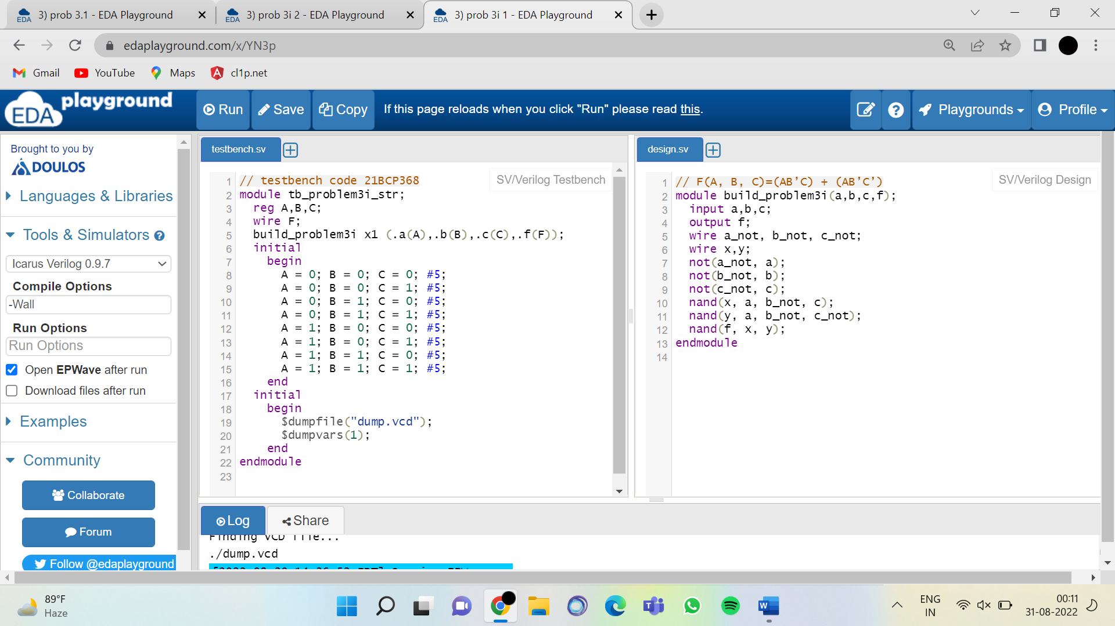

FIG 3.4 Structural code of Verilog for given expression

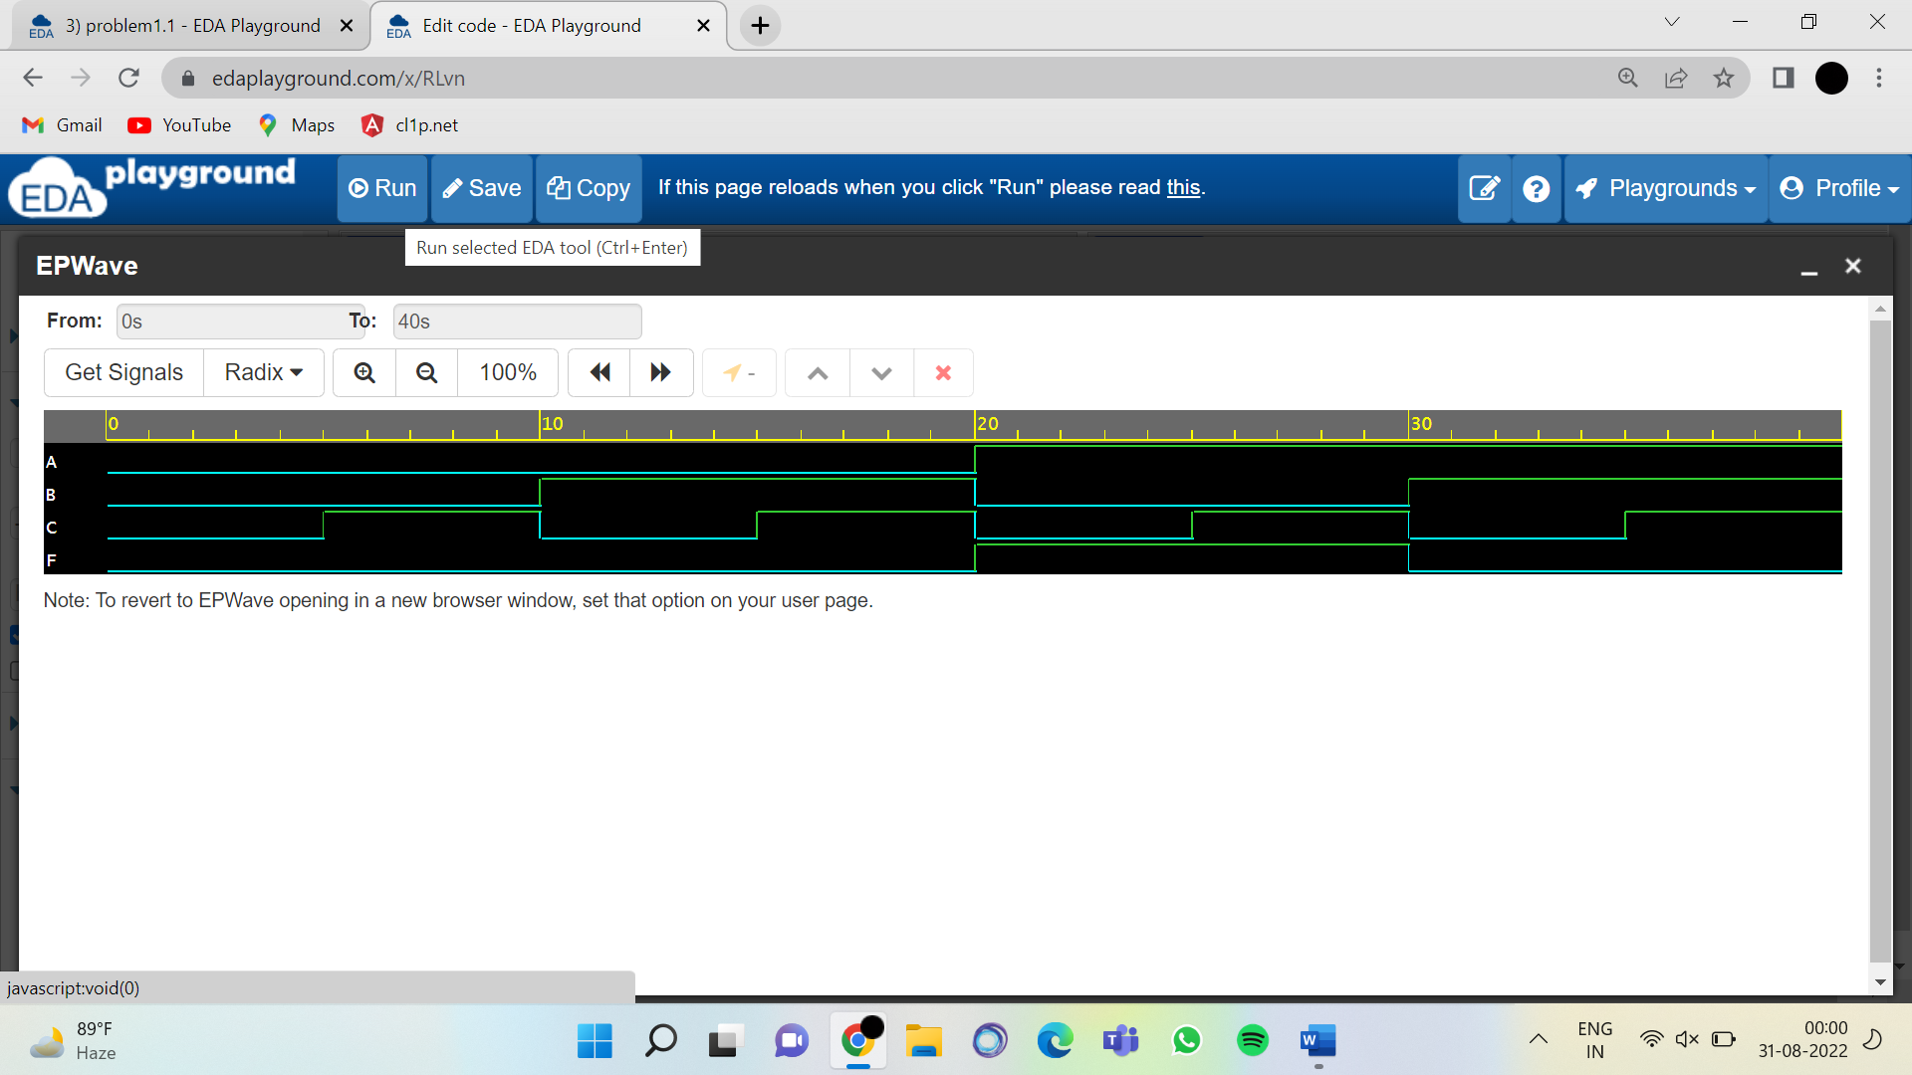

2.F(A, B)= A’B’ + AB’ + A’B + AB

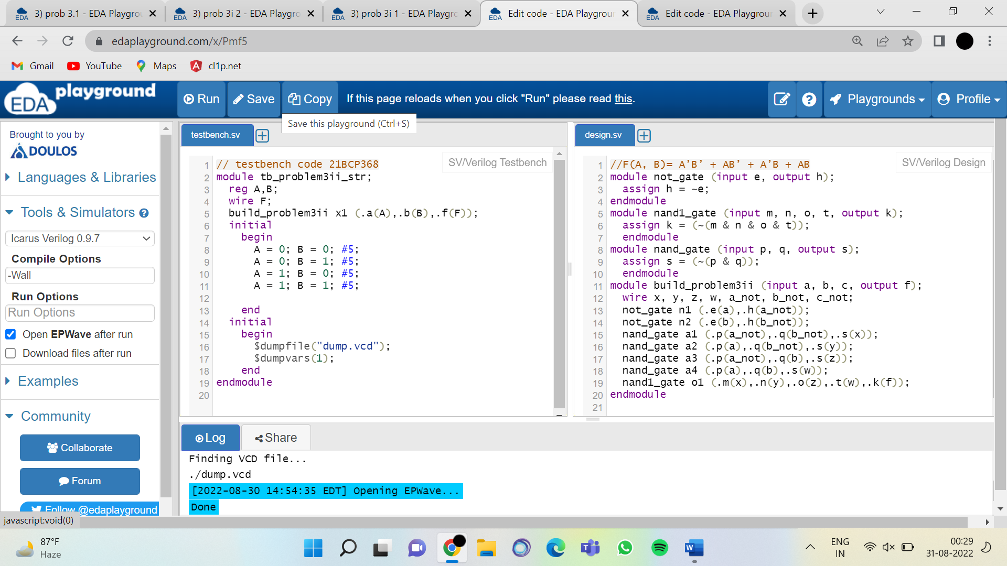

FIG 3.6 Behavioural code of Verilog for given expression

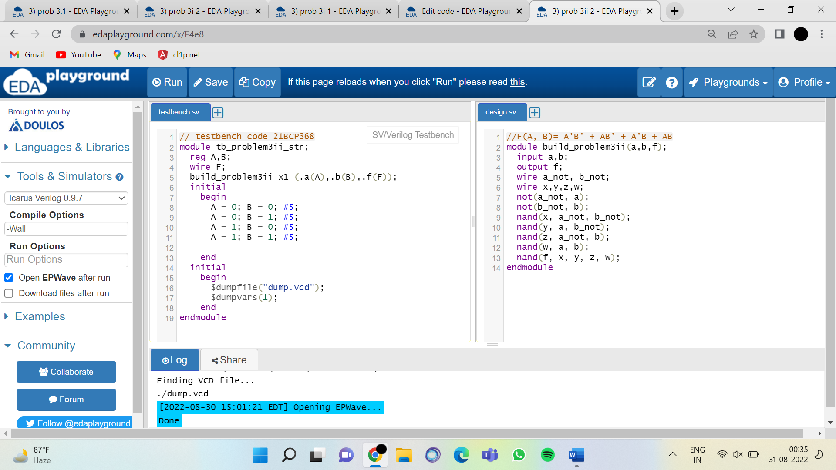

FIG 3.7 Structural code of Verilog for given expression

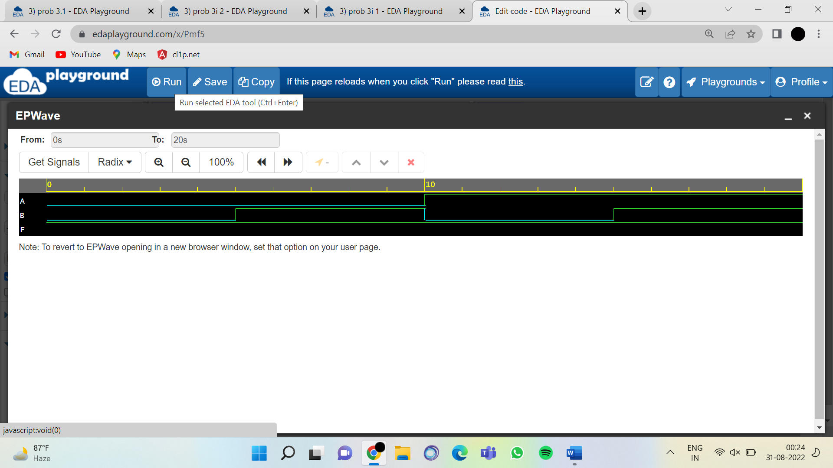

Question: 4 Write down three modules in a single Verilog code to design AND, OR and NOT gate. Now use those modules to design the XOR gate. Use AND, OR and NOT gate as the instances to implement the XOR gate. Write the corresponding Testbench code for the verification of your XOR gate.

Truth Table of XOR Gate:

|  |  |  |
| --- | --- | --- |
| A | B | Y |
| 0 | 0 | 0 |
| 0 | 1 | 1 |
| 1 | 0 | 1 |
| 1 | 1 | 0 |

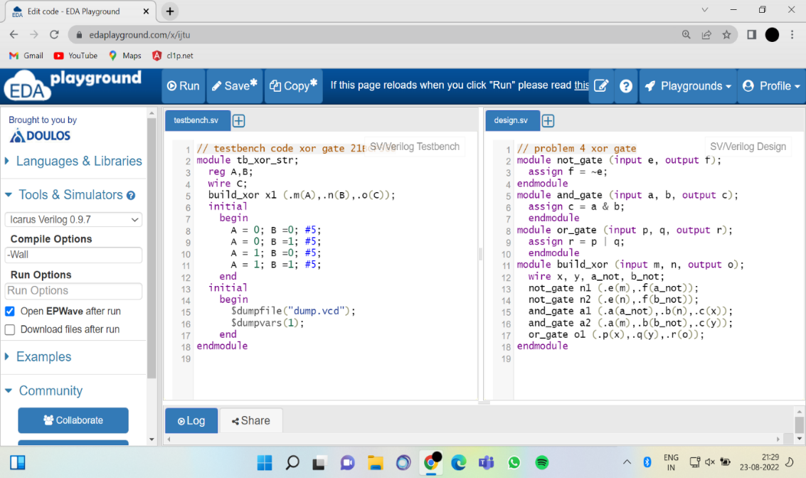

FIG 4.1 Testbench code for the verification of your Verilog code for XOR Gate

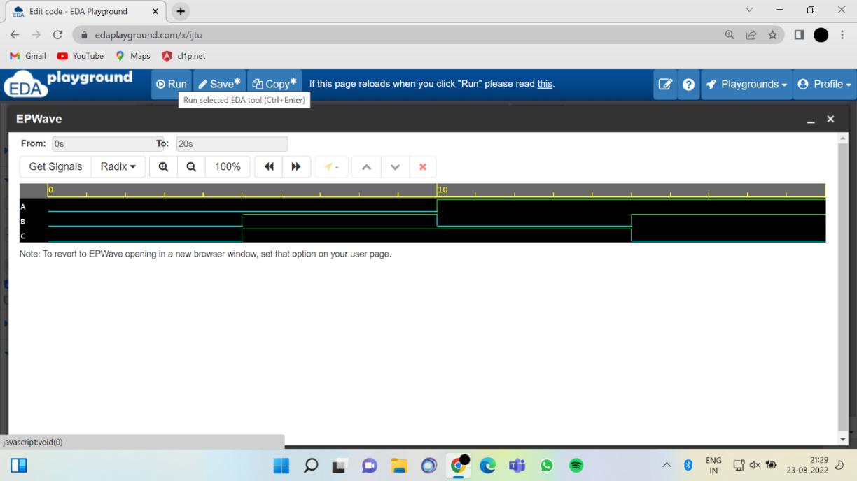

Question: 5 Consider the following expression:

D = A’.B’.C’+ A’.B.C’+ A.B’.C’+ A.B’.C

1. Generate the Truth Table manually for the same.
2. Design one three input ‘And’ gate module and one four input ‘OR’ gate module using Verilog. Instantiate those two modules to design the above-mentioned expression. Design the corresponding TestBench code for the verification purpose.

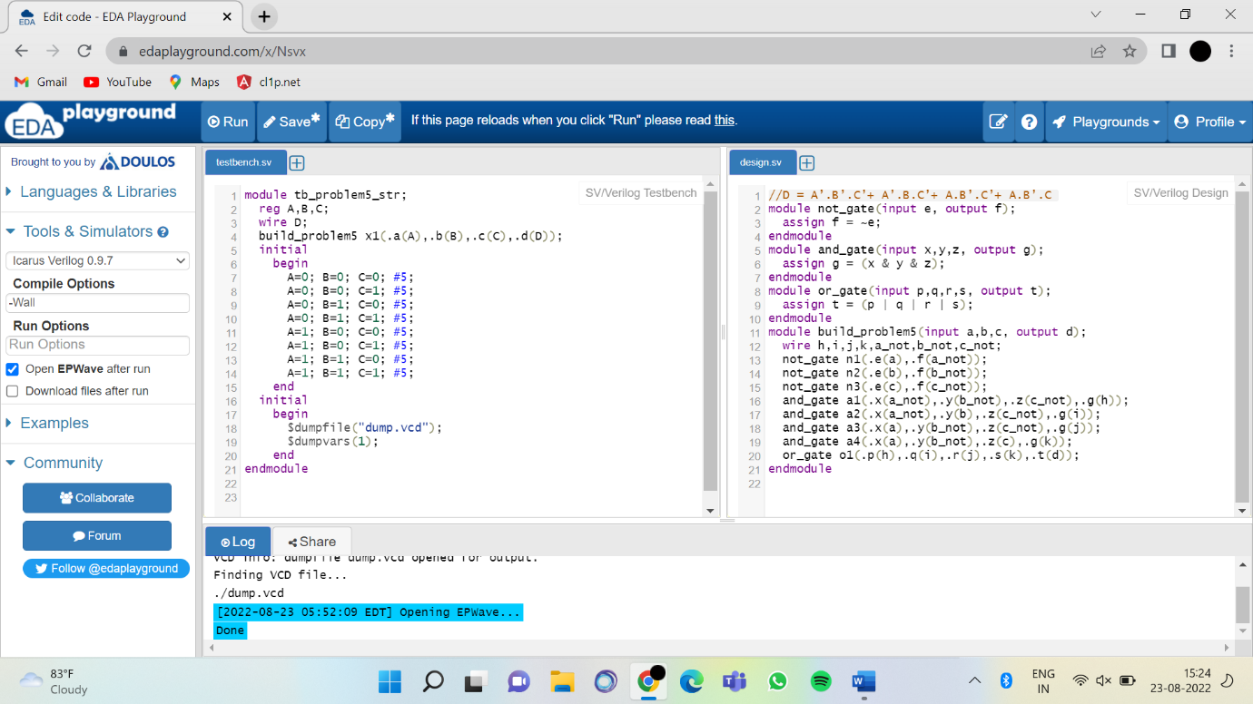FIG 5.3 Testbench code for the verification of your Verilog code for given expression

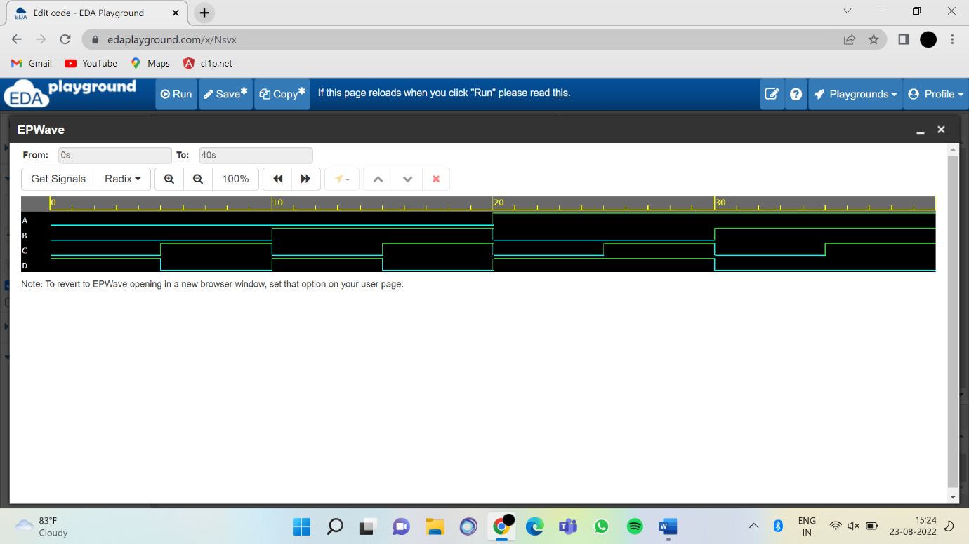

FIG5.4 Output of Verilog code to given expression

1. Now Minimize the given expression.

ANS D = A’C’ + AB’

1. Design again ‘AND’ gate and ‘OR’ gate module with required number of inputs and instantiate them to implement the minimized expression. Design the corresponding TestBench code for the verification purpose.

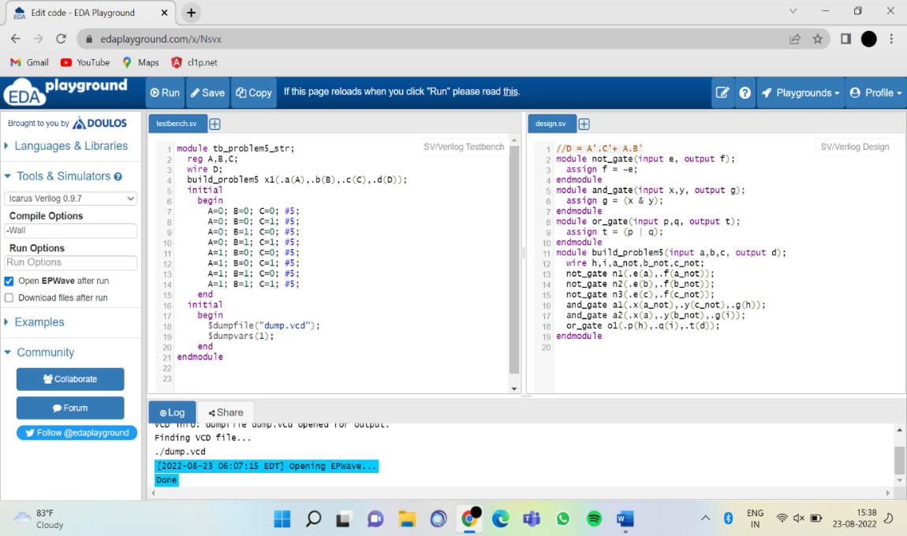

FIG 5.5 Testbench code for the verification of your Verilog code for given minimize expression

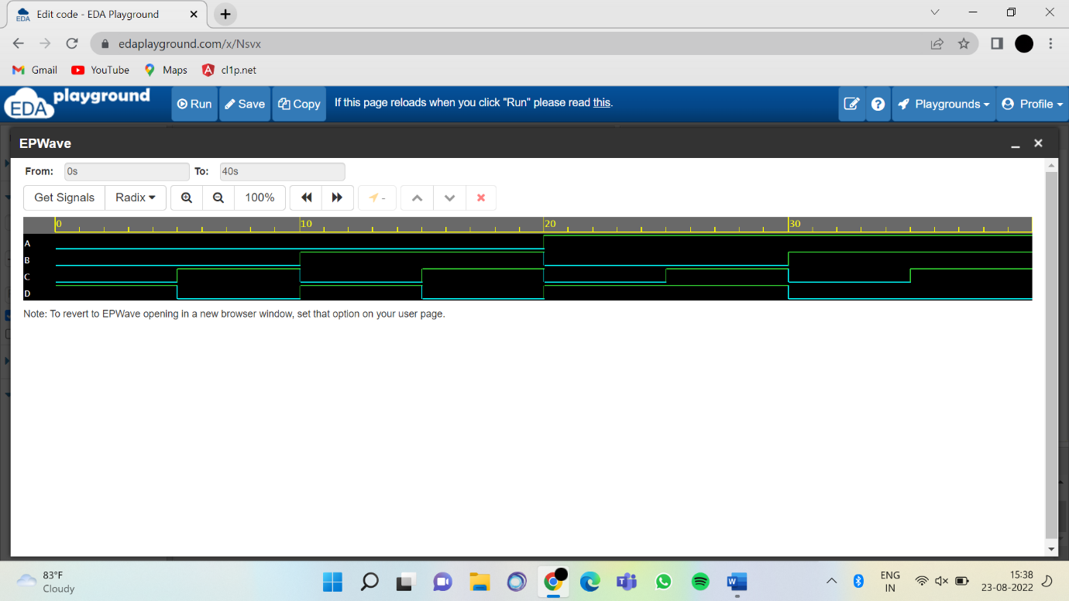

FIG5.6 Output of Verilog code to given expression